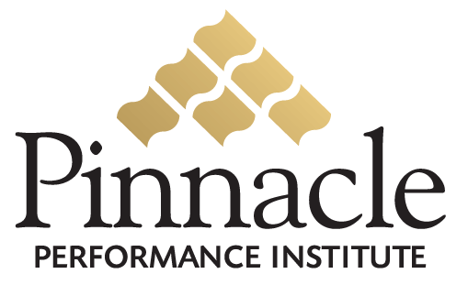

Customer Business Benefits

Dedicated Expertise
By partnering with Pinnacle, Companies can benefit from Pinnacle’s dedicated technical and business expertise in delivering a professional quality solution to maximize the performance of the Company team. Companies can continue to focus on their core competency without risking the quality of the solution with an in-house developed side-project.

Advanced Technology
Pinnacle provides advanced technology architected for large enterprises to support scalability with a multi-tier client-server architecture, flexibility for quick modification to meet changing business requirements, maintainability with industry standard technology, and dynamic multi-lingual support for international markets. Pinnacle provides an enterprise quality web-system far superior to the standard web sites built by typical web designers and programmers.

Immediate Solution
Pinnacle provides a quality solution ready to implement immediately to capitalize on the current window of opportunity. Pinnacle overcomes the challenges that all companies face in developing the necessary systems to meet their fast-paced and ever-changing business objectives. Comparable systems can take a development team 12 to 18 months at least to design, develop and deploy, assuming they have the technical and business expertise.

Customer Performance Benefits

Performance Metrics
Establish where you are and where you’re going

Confidence & Competence
Enable your team members to effective execute your business objectives

Multi-directional Communication
Clearly convey the leadership vision, the team experience, and the customer relationship

